ITEM DETAILS
Name of Item | Federation Mansion
Other Name/s  Former Name/s | 72-76 Campbell Parade, Bondi Beach
Item type | Built
Item group | Flat Building
Item category | Flat
Area, Group, or Collection Name | Unknown
Street number | 72-76
Street name | Campbell Parade
Suburb/town | Bondi Beach |  |  |  |  | Postcode |  |  | 2026
Local Government Area/s | Waverley
Property description | SP 15206
Location - Lat/long | Latitude | -33.892168 |  | Longitude | 151.272867
Location - AMG (if no street address) | Zone |  |  | Easting |  |  |  | Northing
Owner | Private
Current use | Residential and retail
Former Use | Residential and retail
Statement of significance | 72-76 Campbell Parade Bondi, Pacific Mansions and Majestic Mansions (c1915) is a fine and substantially intact example of late Federation flat building above the ground floor on Campbell Parade that illustrates the key period of development of Campbell Parade and Bondi Beach.  It demonstrates the development of O’Brien estate by Chambers and Jacques in 1910 and the first phase of the development of Campbell Parade with flat buildings, which reflects the changing demographics with a shift to living in flats and the growing popularity of the beach in the early 20th century.  The modification of the ground floor to retail demonstrates the growing importance of Campbell Parade as a retail strip servicing the increasing local population and recreational visitors to Bondi in the Inter-War period.  The building is a notable example of development of flat building along Campbell Parade with later retail overlay and is distinctive because of its scale prominence and corner location.
Level of Significance | National |  | State |  |  |  | Local

DESCRIPTION
Designer

Builder/ maker | William Hill Miller
Physical Description | 72-76 Campbell Parade Bondi, Pacific Mansions and Majestic Mansions is a four-storey flat building with later ground-floor retail that is part of a group that dates from the early Inter-War period, c1915. The building displays some features of the Federation Arts & Crafts style including projecting bays and rough-cast walling. The building is set to the front alignment on a large corner site approximately 36 metres wide, that has been amalgamated within a retail strip setting that has retained much of its historic context.  The building is in good condition and substantially intact.  Elements impacting upon the integrity of the site include shop front and awning, enclosed balconies, and rear balconies.
Physical condition  and  Archaeological potential | The building appears to be in good condition
Construction years | Start year |  | Finish year |  | Circa | c1915
Modifications and dates | Ground floor retail was added at a later date.

HISTORY
Historical notes | 72-76 Campbell Parade, Bondi were part of Lot 10, 11, & 12 of Chambers & Jacques subdivision of O’Brien’s Bondi Beach Estate 1910. Lot 11 was purchased by Aerated Bread Co. Ltd in March 1911 (2131-230). Lot 10 was purchased by Henrietta Augusta Kilmer of Bondi in 1912 (2233-103)  Lot 12 was purchased by Albert Ray in April 1914 (2476-95). Ray had purchased lots 10 & 11 the previous month. In July 1915, William Hill Miller, a builder of Lewisham purchased lots 10, 11 & 12 from Albert Ray. The building was constructed by Miller on the consolidated lot in the second half of 1915.  Between 1915 and the mid 1930s, Campbell Parade and Bondi Road underwent a process of transformation when residential flat buildings and commercial buildings were erected along the beachfront. The building now Nos. 72-76 Campbell Parade was described as 'nearing completion' in an advertisement in The Sydney Morning Herald on 11 December 1915. The building was first listed in John Sands' Sydney and Suburban Directories in 1917. This information provides a construction date of c.1915. Sands' Directories lists what are now Nos. 72-76 Campbell Parade from Bondi Road under the names Pacific Mansions and Majestic Mansions until the last published directory of 1932-33. When Pacific Mansions was renamed as Grenfell Mansions is not known. (FN Heritage Impact Statement, 72-76 Campbell Parade Bondi Beach, Weir Phillips pg3). In April 1921, part of the lots was sold off with right of way. It appears that ground-floor retail was added later.  Notably, the National Trust’s Statement of Significance for its heritage listing of the Bondi Pavilion and the Bondi Beach Urban Conservation Area both note the significance of the buildings fronting Campbell Parade. The reasons are:  The scale of Bondi Beach and the pronounced functional and visual integration with its historically significant foreshore development is a rare 1920s urban landscape within the context of any city in the world.  The development of Bondi Beach has significance in the historical development of Sydney. The Bondi Beach area features some typical twenties “boomtime” architecture. The two international hotels, the Bondi and the Astra, the Spanish Revival-style Bondi Pavilion and the modest flat buildings are all evocative of Bondi becoming more cosmopolitan and Sydney siders becoming recreationally oriented towards the ocean coast.  The Statement of Cultural Significance in the 2018 CMP for the Bondi Pavilion also notes:  The Bondi Pavilion is representative of 1920s Mediterranean architectural style and its setting is representative of 1920s town planning, which in a beach front location on the scale at Bondi is now unique in Sydney. The Bondi Pavilion is a key townscape element at Bondi Beach, providing a major contribution to the townscape and character of the locality and is a key element of the Bondi Beach Cultural Landscape. The assessment of significance of site elements includes the visual and physical relationships between the Bondi Pavilion and:  • its landscaped setting in Bondi Park and  • the cultural landscape in Bondi beach, including the beach, Campbell Parade and the wider environs of Bondi Bay and  • the Bondi Surf Bathers Life Saving Club Clubhouse  Research carried out for the draft Bondi Beach Cultural Landscape CMP, submitted to the Heritage Office for endorsement in 2023, states that there are additional aspects of significance not yet captured in existing Statements of Significance and that updates are required to include the buildings that line Campbell Parade that are contemporaneous with the Pavilion and beach improvement scheme:  It became clear that Bondi Beach is valued for its sense of place as an urban beach - the result of the natural environment and successive improvement schemes and forming an integrated designed landscape. The crescent-shaped, wide, gently sloping, sandy beach is enclosed by headlands on each side, the curved sea wall, bank of parkland and contemporary buildings lining Campbell Parade.  The CMP offers a revised Statement of Significance for the Bondi Beach Cultural Landscape be considered in future, including:  Designed with a hierarchy of buildings of complimentary architectural style, the surf pavilion was the centrepiece, with smaller surf clubs and even smaller utilitarian structure and enclosed to the west by the contemporary buildings lining Campbell Parade.  Part E of the Waverly DCP includes Site Specific Development. Part E2 addresses the Bondi Beachfront area. The Bondi Beachfront area generally surrounds the CMP study area with some small exceptions. Part E2 of the DCP contains objectives and controls for the area (public domain interface, built form, use, roofs, views, heritage conservation, infill) as well as specific objectives and built form controls for the following five Character Areas:  • Notts Avenue;  • Campbell Parade South;  • Campbell Parade;  • Campbell Parade North; and  • Ramsgate Avenue East.  Within each of these character areas the desired future character, the identified LEP heritage and other Contributory buildings are identified.

THEMES
 | National historical theme | 3 Developing local, regional and national economies  4 Building settlements, towns and cities
 | State  historical theme | Transport  Towns, suburbs and villages  Land tenure  Accommodation  Domestic life  Leisure
 | Local  historical theme | Traffic and Transport  Leisure and Recreation  Flats and Bungalows  Speculation and Subdivision

Assessment
A: Historical Significance | 72-76 Campbell Parade, Pacific Mansions, and Majestic Mansions, has historical significance at a local level as it demonstrates the development of O’Brien estate by Chambers and Jacques in 1910 and the first phase of the development of Campbell Parade with flat buildings, which reflects the changing demographics with a shift to living in flats and the growing popularity of the beach in the early 20th century.  The modification of the ground floor to retail demonstrates the growing importance of Campbell Parade as a retail strip servicing the increasing local population and recreational visitors to Bondi in the Inter-War period.
B: Associative | To date no historic association has been identified.
C: Aesthetic significance | The building is a notable example of the development of flat buildings along Campbell Parade with later retail overlay.  72-76 Campbell Parade, Pacific Mansions and Majestic Mansions, has aesthetic significance at a local level as they are a fine and substantially intact late Federation Arts & Crafts flat building with a later retail overlay which is distinctive because of its scale, prominence and corner location.  The building shows an accomplished use of Federation Arts & Crafts style which features projecting bays and rough-cast walling.
D: Social significance | To date no social, cultural, and spiritual significance has been identified.
e) Technical/  Research significance | To date no technical significance has been identified.
f) Rarity | To date the research indicates 72-76 Campbell Parade, Pacific Mansions, and Majestic Mansions, is not rare.
g) Representative-ness | 72-76 Campbell Parade, Pacific Mansions and Majestic Mansions, has representative significance at a local level as it is a fine and substantially intact example of late-Federation flat building above the ground floor on Campbell Parade that illustrates the key period of development of Campbell Parade and Bondi Beach.
Integrity | The building is substantially intact.

HERITAGE LISTINGS
Heritage listing/s | Draft Waverley LEP 2012

INFORMATION SOURCES
Type | Author/Client | Title | Year | Repository
 | Waverley Council | Waverley Heritage Policy | 2007
 | Waverley Council | Waverley Heritage Study | 1993
 | Perumal Murphy Pty Ltd | Waverley Heritage Study | 1990
 |  | Certificate of Title, Vol 2131 Fol230 |  | NSW Land Registry Services
 |  | Certificate of Title, Vol 2233 Fol103 |  | NSW Land Registry Services
 |  | Certificate of Title, Vol 2476 Fol95 |  | NSW Land Registry Services
Newspaper articles | Sydney Morning Herald | 11 December 1915 | 1915 | National Library Australia
 |  |  | 1932-3 | Sands Directory
 | Weir Phillips | Heritage Impact Statement, 72-76 Campbell Parade Bondi Beach, pg3

RECOMMENDATIONS
Recommendations

SOURCE OF THIS INFORMATION
Name of study or report | Heritage Policy by Waverley Council reviewed by Architectural Projects 2023 |  | Year of study or report
Item number in study or report

Author of study or report
Inspected by
NSW Heritage Manual guidelines used? |  |  |  | Yes |  | No
This form completed by |  |  |  | Date

IMAGES

Image caption | 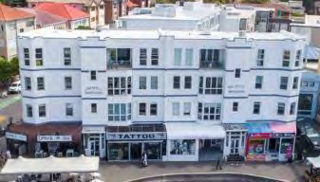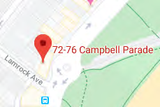
Image year |  | Image by | Google Maps | Image copyright holder

Image caption | 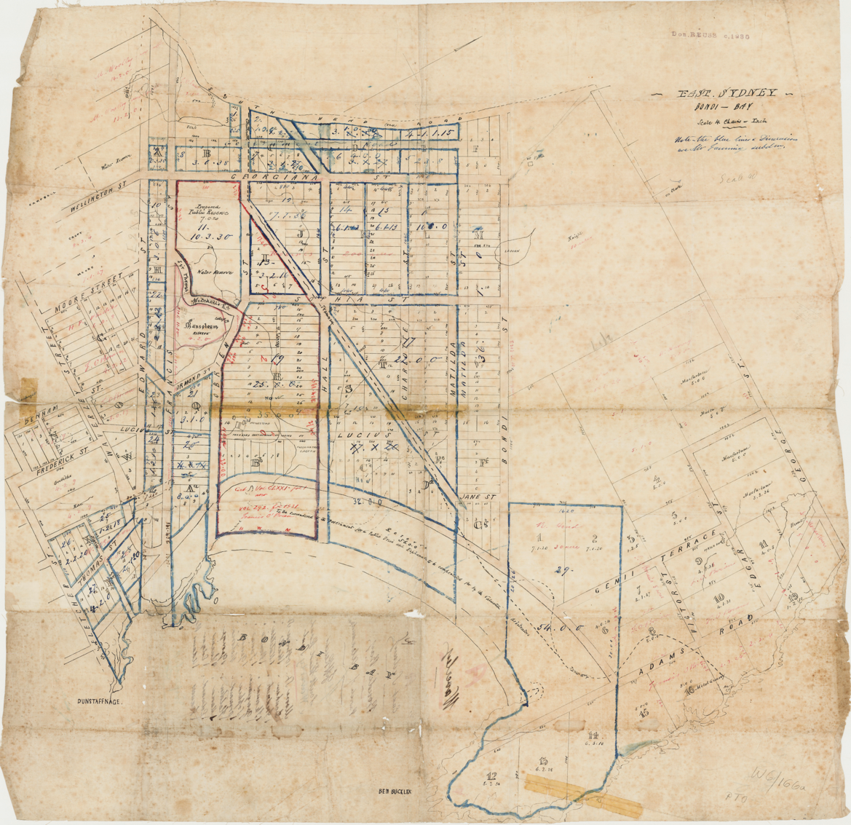
Image year | Undated | Image by | State Library of New South Wales | Image copyright holder

Image caption | 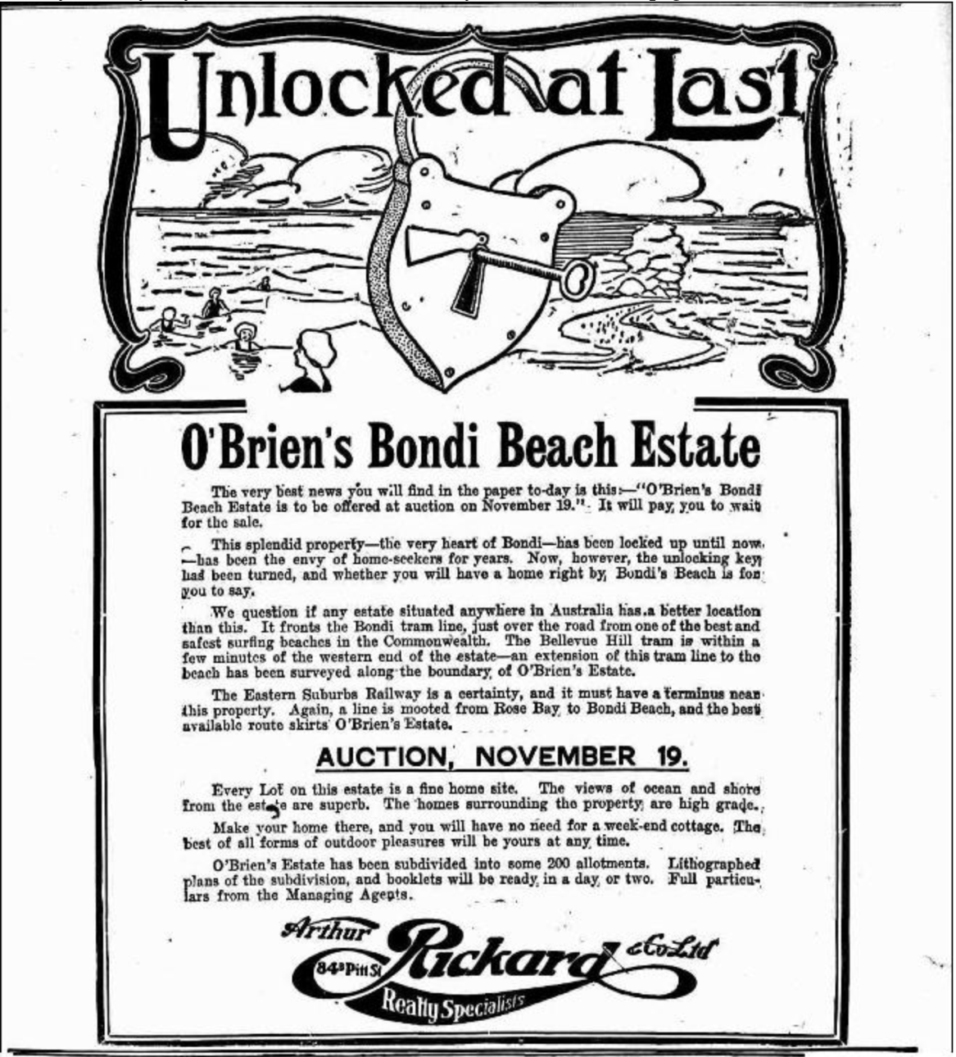
Image year | 1910 | Image by | NLA Trove | Image copyright holder

Image caption | 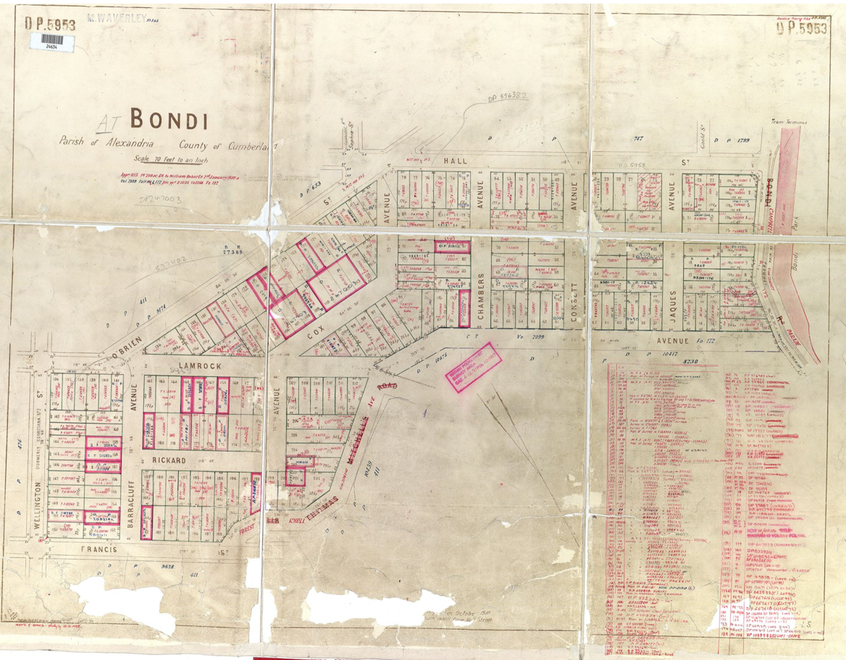
Image year | Undated | Image by | LPI | Image copyright holder

